Project Scheduling
The objective of project scheduling tools is to enable a project manager to define work tasks; establish their dependencies; assign human resources to tasks; and develop a variety of graphs, charts, and tables that aid in tracking and control of the software project
Critical Path Method (CPM) in Project Management?
The critical path in project management is the longest sequence of tasks that must be completed to finish a project. It's the path that takes the longest to complete from start to finish, and it determines the minimum amount of time needed to finish a project

What are PERT charts?
The activity durations computed using an activity network are only estimated duration. It is therefore not possible to estimate the worst case (pessimistic) and best case (optimistic) estimations using an activity diagram. Since, the actual durations might vary from the estimated durations, the utility of the activity network diagrams are limited. The CPM can be used to determine the duration of a project, but does not provide any indication of the probability of meeting that schedule.
Program Evaluation Review Technique (PERT) charts show each task in a project as a node. Dependencies between tasks (e.g. where one task requires another one to be completed before it can start) are clearly shown by interconnections between the task nodes. PERT charts also show timing information for each task. PERT charts are similar to the critical path method (CPM) which identifies the longest path through the project, and therefore the minimum time for the project to be completed.
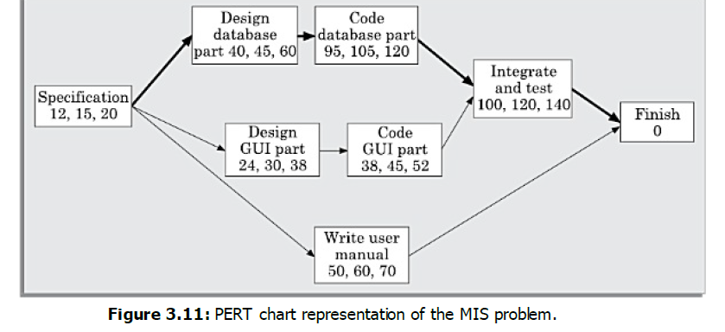
Project managers can use PERT charts to:
set a realistic timetable for project completion make sure focus is maintained on the most critical tasks for the critical path – since the path leads to the minimum time the project requires, any delays to these tasks will result in a delay to the overall project identify tasks that need to be shortened if the overall project time needs to be reduced identify tasks that can be carried out simultaneously identify slack time where certain tasks are not as time-critical to the overall deadline. Whereas CPM uses a single estimate for task duration, the PERT method requires the project manager to supply three estimates to make the estimates as accurate as possible. The three estimates are:
Optimistic Time (O) – the shortest time that the activity is likely to take. There will be a small
probability (less than 5%) of this happening
Most Likely Time (M) – the project manager should have a high degree of certainty that the
task will be completed within this time
Pessimistic Time (P) – the project manager should be almost certain (e.g. 99%) that the task
will be completed within this time
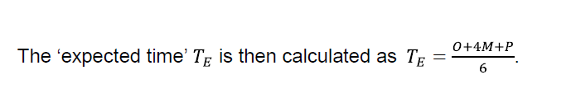
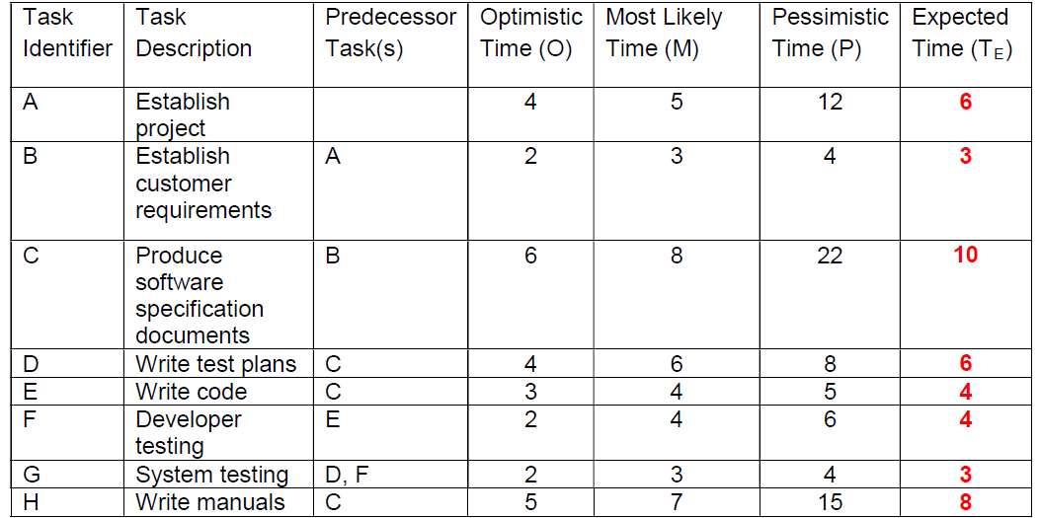

Network Diagram:
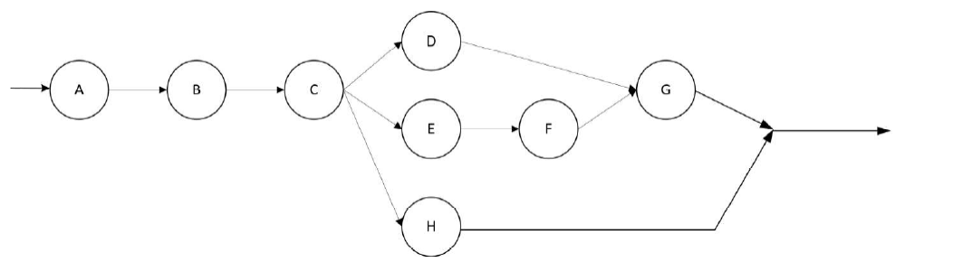
Forward and Backward pass
